NUID: - 002193783

Program Structure and Algorithms 6205 Section 6.

ASSIGNMENT 2

Task: - We need to find the time of execution that it takes to execute any particular function. It is dependent on out machines. We are checking the execution time by taking the time of execution of insertion sort by giving it arrays to sort, which will be random random, ordered, partially ordered and reverse-ordered. And we will be checking this by increasing the size of the array and giving them random numbers.

**Output while executing the Main Function**: -

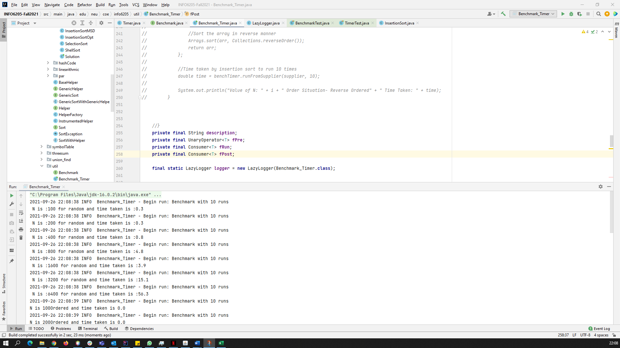

Evidence: -

|  |  |  |  |  |  |  |  |  |  |  |  |  |  |  |  |  |  |  |  |  |  |  |  |  |  |  |  |  |  |  |  |  |  |  |  |  |  |  |  |  |  |  |
| --- | --- | --- | --- | --- | --- | --- | --- | --- | --- | --- | --- | --- | --- | --- | --- | --- | --- | --- | --- | --- | --- | --- | --- | --- | --- | --- | --- | --- | --- | --- | --- | --- | --- | --- | --- | --- | --- | --- | --- | --- | --- | --- |
| |  |  |  |  |  | | --- | --- | --- | --- | --- | | Number of Steps (n) | Random | ordered | Partially | Reverse ordered | | 100 | 0.3 | 0 | 0 | 0.0 | | 200 | 0.3 | 0 | 0 | 0.1 | | 400 | 0.8 | 0 | 0.1 | 0.4 | | 800 | 4.8 | 0 | 0.3 | 1.4 | | 1600 | 3.9 | 0 | 1.4 | 6.5 | | 3200 | 15.1 | 0 | 6.1 | 26.3 | | 6400 | 56.3 | 0 | 24.3 | 103.5 | | |  |
|  |  |  |
|  |  |  |
|  |  |  |
|  |  |  |
|  |  |  |